Memristors HW-1

Chris Shakkour – 208157826 – [christians.s@campus.technion.ac.il](mailto:christians.s@campus.technion.ac.il)

Nadi Najjar – 211610704 – [nadi.najjar@campus.technion.ac.il](mailto:nadi.najjar@campus.technion.ac.il)

Contents

Question 1 – Ideal Memristor 2

Part a 2

Part b 3

Part c 5

Part d 7

Question 2 – Memristor modeling in MATLAB 9

Part a 9

Part b 10

Part c 12

Question 3 –Memristor simulation in LTspice(linear drift) 16

Part a 16

Part b 16

Part c 18

Part d 18

Part e 19

Part f 19

Part g 20

Question 4 –Memristor simulation in LTspice(binarized model) 21

Part a 21

Part b 21

Part c 22

Part d 23

# Question 1 – Ideal Memristor

## Part a

the flux is calculated as follows:

Given the following plot is generated where the Y axis is the flux and the X axis is the charge.

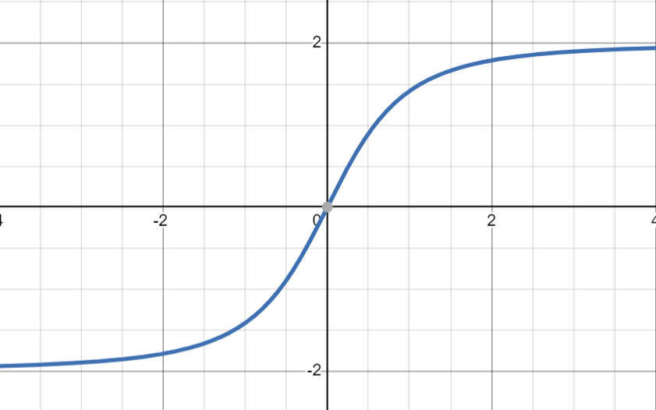

Figure - flux-charge curve

## Part b

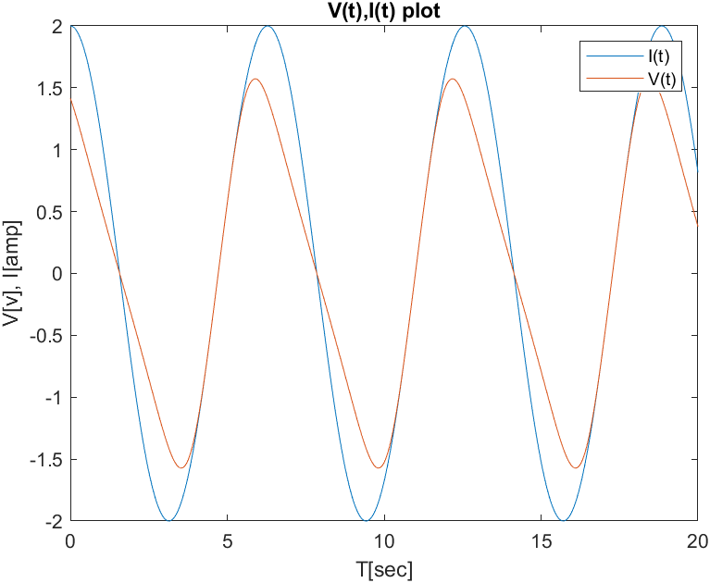

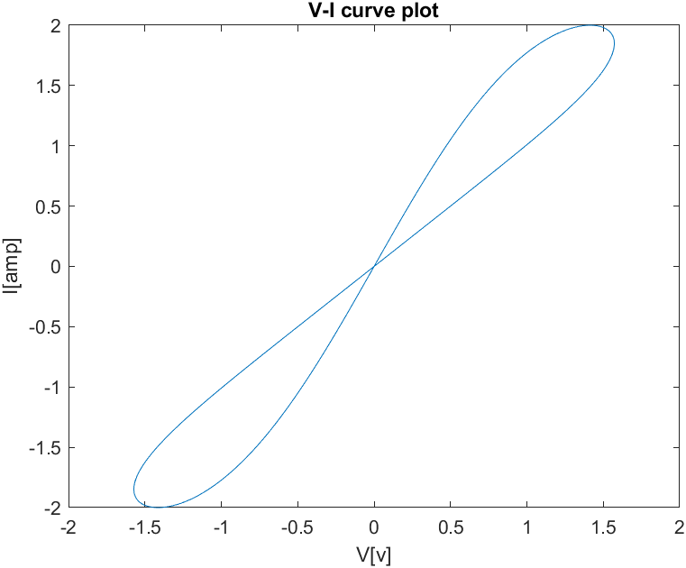

## Part c

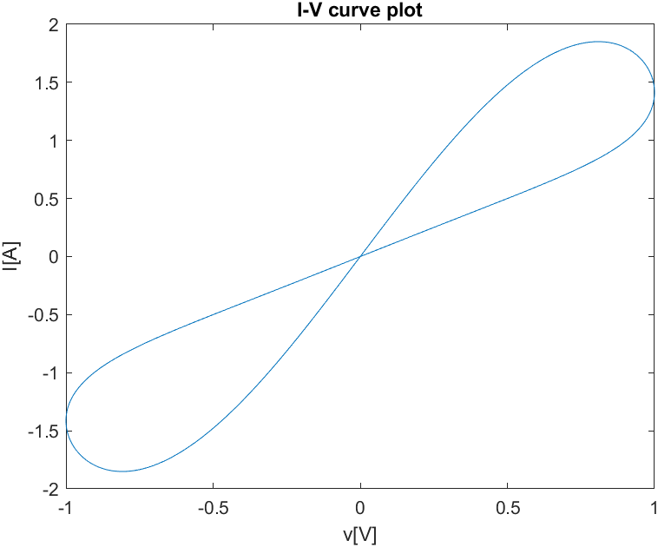

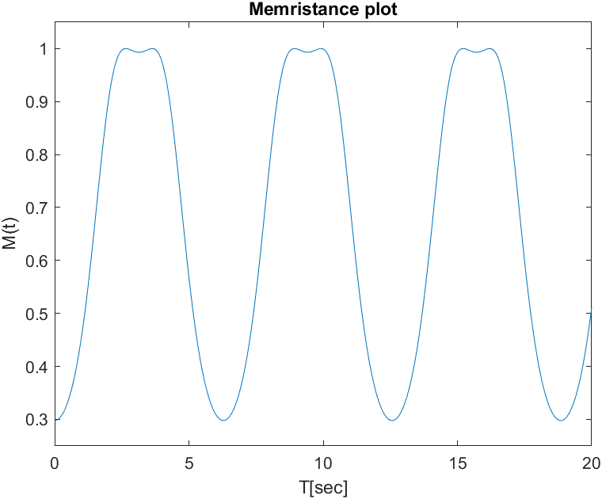

## Part d

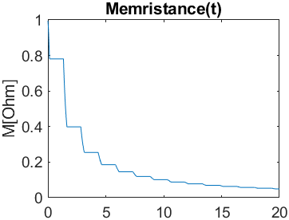

# Question 2 – Memristor modeling in MATLAB

## Part a

Given a sine wave voltage source:

Prodromakis’s window function is defined as follows:

The change in is defined as follows:

Hence to calculate we will integrate over as follows:

The current however is calculated by the following equation.

## Part b

Given the following parameters:

|  |  |
| --- | --- |
| param | value |
|  | 0.3 |
|  | 1 |
|  | 0.5 |
|  | 11 |
|  | 3 |
|  | 1 |
|  | 130 |
|  | 16K |
|  | 1e-15 |

We plug the equations from “part a” in MATLAB and get the following graphs.

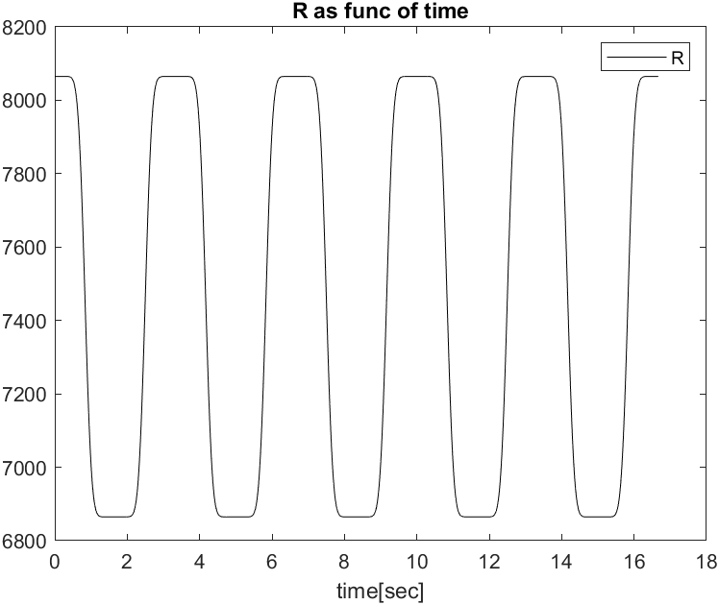

The upper plot shows that the memristor is transitioning from to and vise versa according to the frequency of the power supply, this behavior is expected since the memristor has enough time to transition and adapt to the transient effects, hence the memristor is switching between and .

Same explanation of R graph also implies here since the Resistivity is derived from this graph.

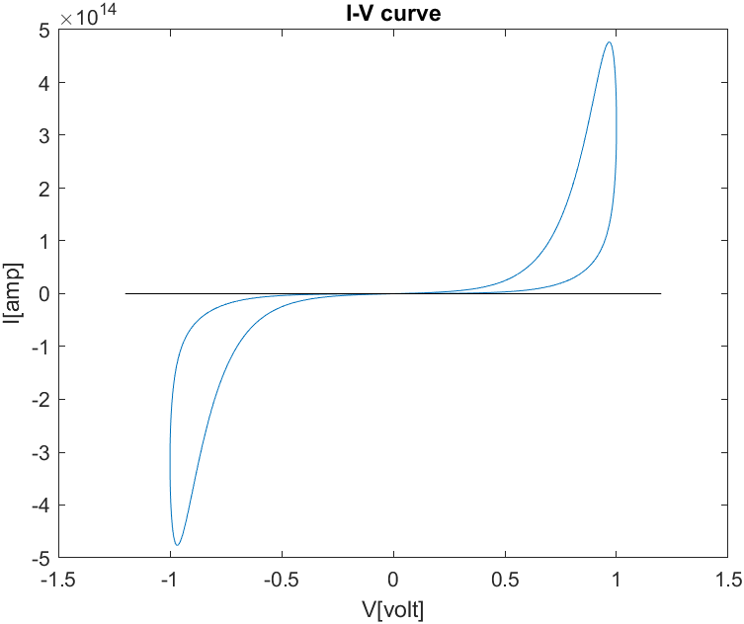

In the I-V curve plot we can see the hysteresis when sweeping the voltage from one direction to the other direction, moving the resistivity between and

## Part c

Given the following parameters:

|  |  |
| --- | --- |
| param | value |
|  | 1 |
|  | 1 |
|  | 0.5 |
|  | 11 |
|  | 3 |
|  | 1 |
|  | 130 |
|  | 16K |
|  | 1e-15 |
|  | 0.01 |

We plug the parameters above into MATLAB and get the following plots.

The current flowing from the power source is shown below:

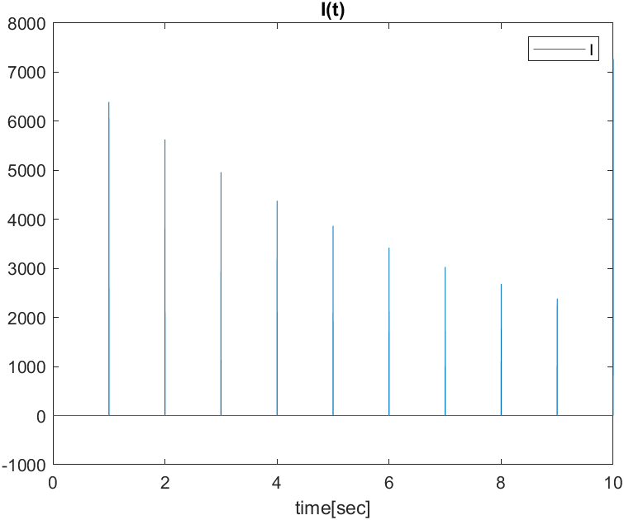

The state variable plot:

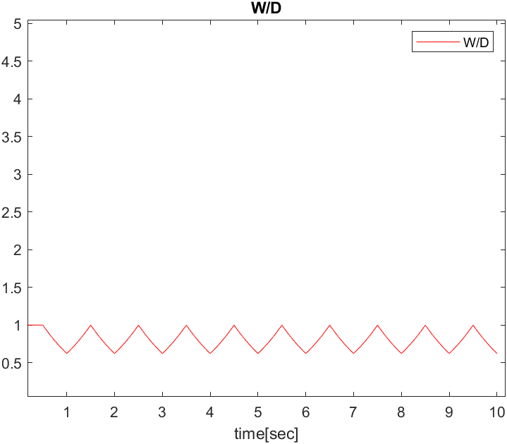

The memristance over time:

Memristor voltage, notice the degradation of the peaks over time.

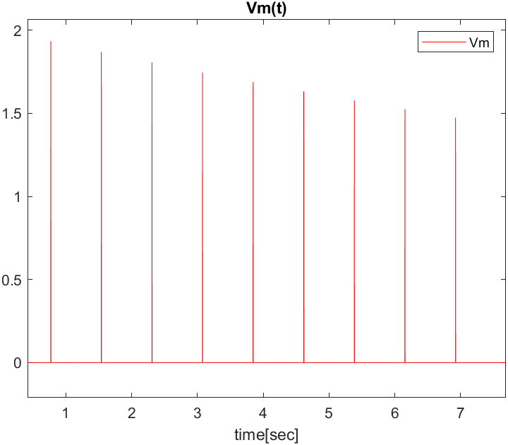

The IV curve changes due to the change in memristance, the memristor is not reaching its potential max memristance hence for every clock cycle the IV curve is changing.

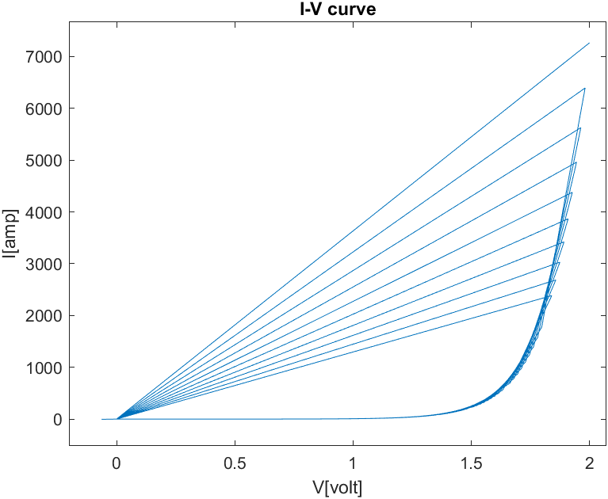

The explanation to the drop in memristance is as follows, the memristor reaches steady state rapidly to and hence the capacitor sees different resistors on the charging and discharging phase hence the overall charge on the capacitor is not Zero again due to lack of symmetry between the charging and discharging phase of the cap. The charge caring on the capacitor over time degridates the ability of the memristor to change since the overall charge manipulation in the circuit is less cycle over cycle due to the stuck charge on the capacitor.

# Question 3 –Memristor simulation in LTspice(linear drift)

## Part a

Joglekar’s window function is defined as follows:

The change in is defined as follows:

Hence to calculate we will integrate over as follows:

The current however is calculated by the following equation.

## Part b

The circuit used for the simulation is the following circuit:

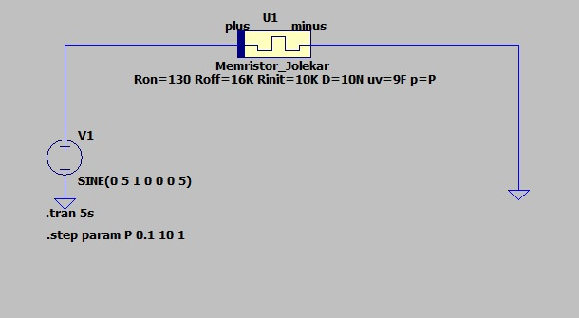

Given the following plots are provided.

**Memristor voltage:**

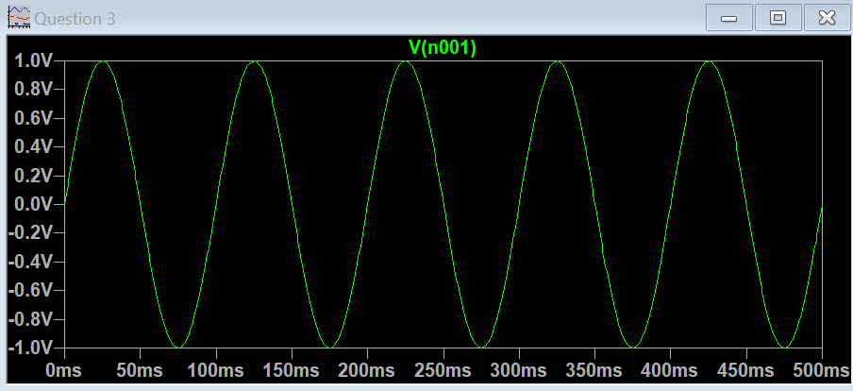

**Memristor current:**

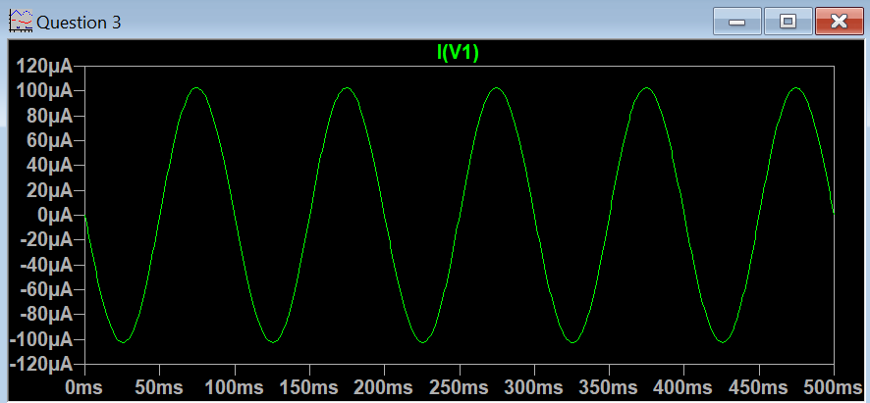

**I-V curve:**

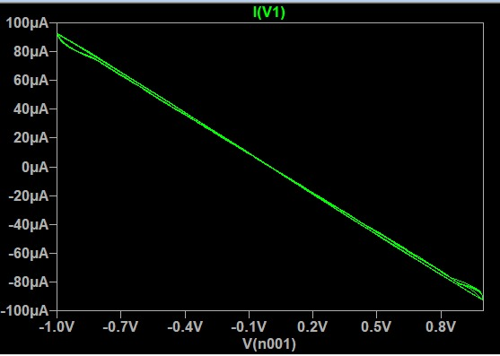

**Charge q = di/dt(current) curve:**

**State variable :**

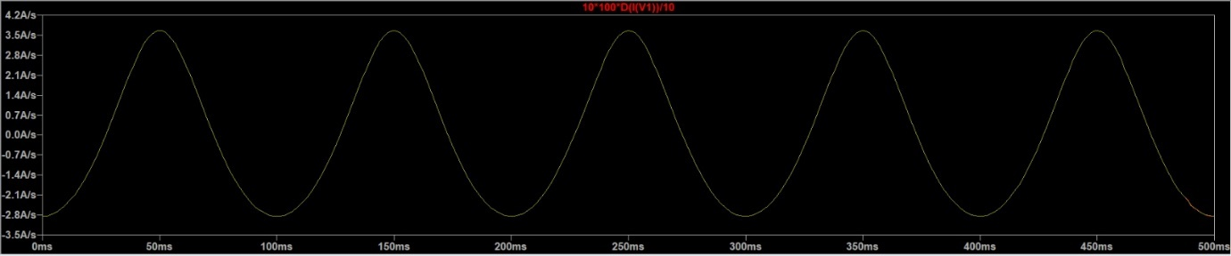

## Part c

The current plot is a bit blended with the background but when zooming one can see that the current is phased almost 90 degrees from the voltage. This behavior is due to the time it takes the memristor to react to the transition on the current.



## Part d

The current spikes in the blue plot occur when the derivative of the state variable reaches the boundaries where an overshoot/undershoot phenomenon is present. in the analytical model once reached the boundary when the memristor is stuck-at and wont change hence the current should be rock stable and not have degrading ripple.

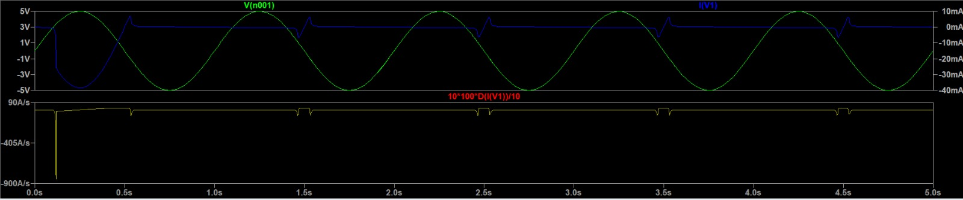

## Part e

In Joglekar’s window function the higher the P the closer the function is to a perfect window function, hence the change in the derivative is higher(steeper). And because of that the overshoot/undershoot has higher amplitudes but shorter in time.

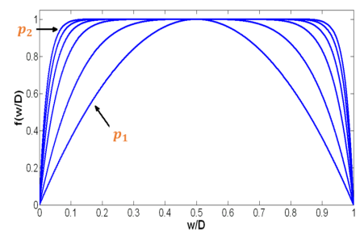

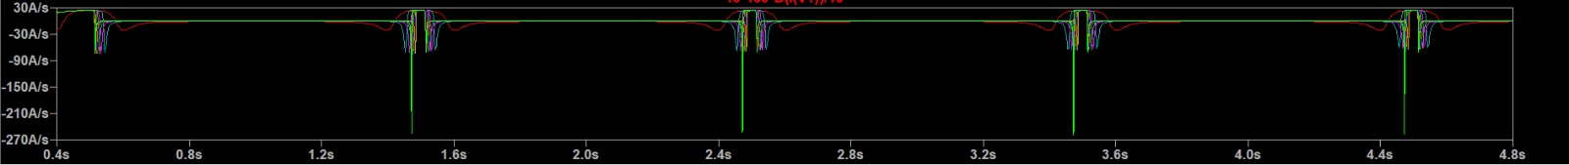

## Part f

The parameter defines the mobility inside the memristor, the higher the mobility the easier the current to flow and transfer the free mobile charges hence we can see degradation of current (blue plot) as we change the mobility. This also impacts the transition speed as well, if ther is more mobile charges It would take less time to start the transfer process hence we see the green plots as shifted a bit left as we change the mobility.

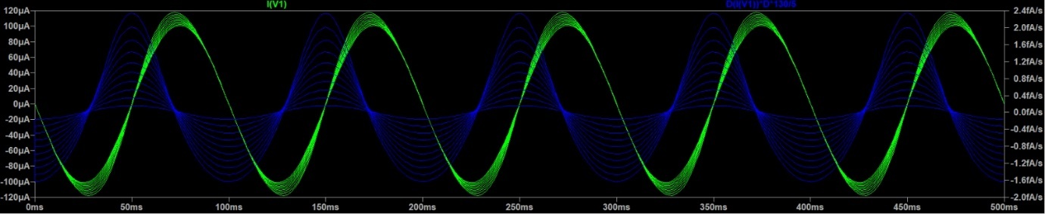

## Part g

The cut-off frequency of the memristor is when it behaves like a fixed value resistor, this event occurs when where the width is fixed and does not change, to find the cut-off frequency of the memristor we will increase the frequency bit by bit and observe the plot of the memristance as follows.

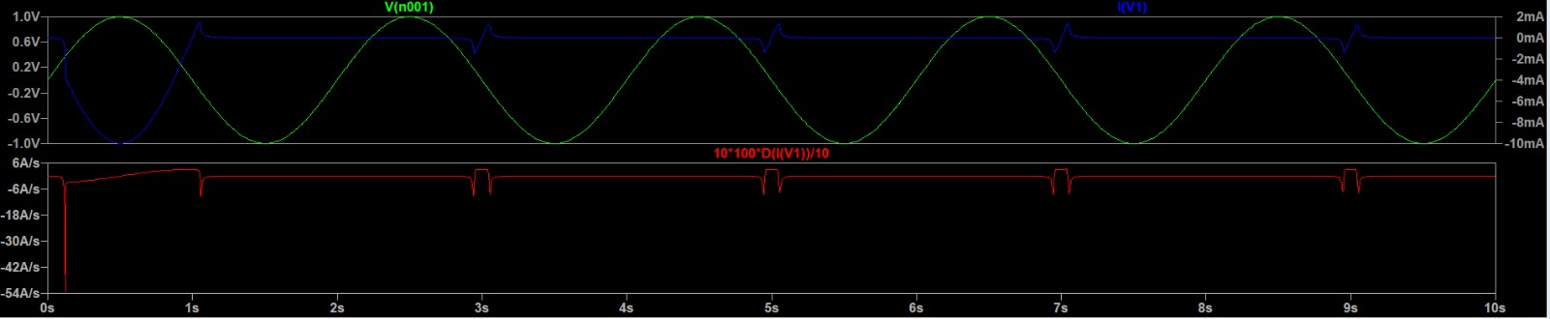

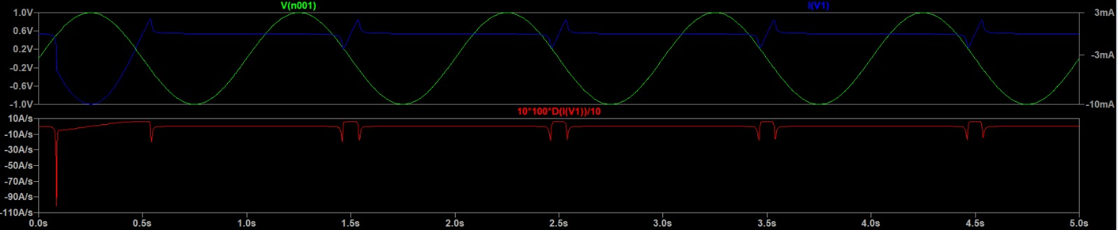

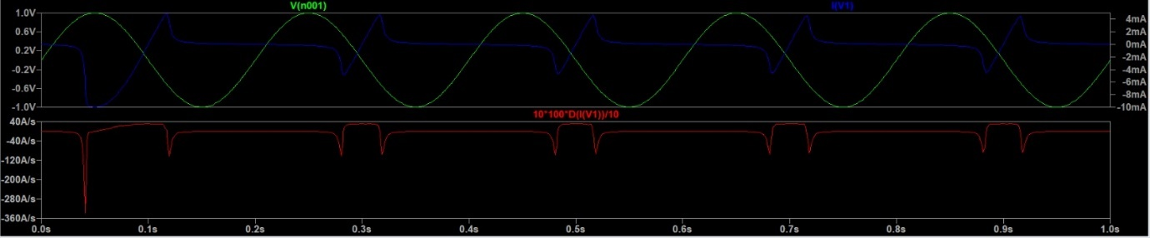

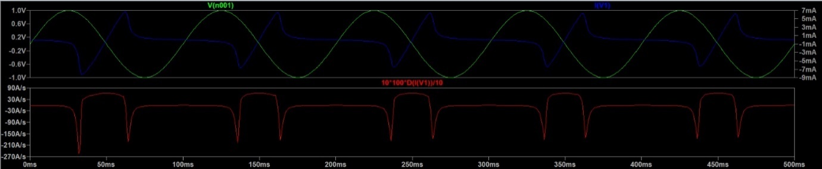

One can see that around most of the transient and ripple effects are negligible and there is not much different in the plots between and hence we can say that the cut-off frequency is approximately

# Question 4 –Memristor simulation in LTspice(binarized model)

## Part a

For the binary memristor, the dependence on the voltage is only whether it exceeds the positive/negative thresholds, and the exponential dependence on x serves to slow the change of x when it approaches more extreme values. This can be considered similar in behavior to a window function in that it reduces the extreme values of x for a given setup, but it is not an explicit window function.

## Part b

The following plots are generated… we can see in the resistivity plot below(in green) the binarized behavior when reaching a voltage limit the resistivity is transitioned between off and on, and vise versa, a model where when the voltage is higher than a certain threshold the resistance transitions to R_on and when the voltage is lower than a certain threshold the resistivity transitions to R_off

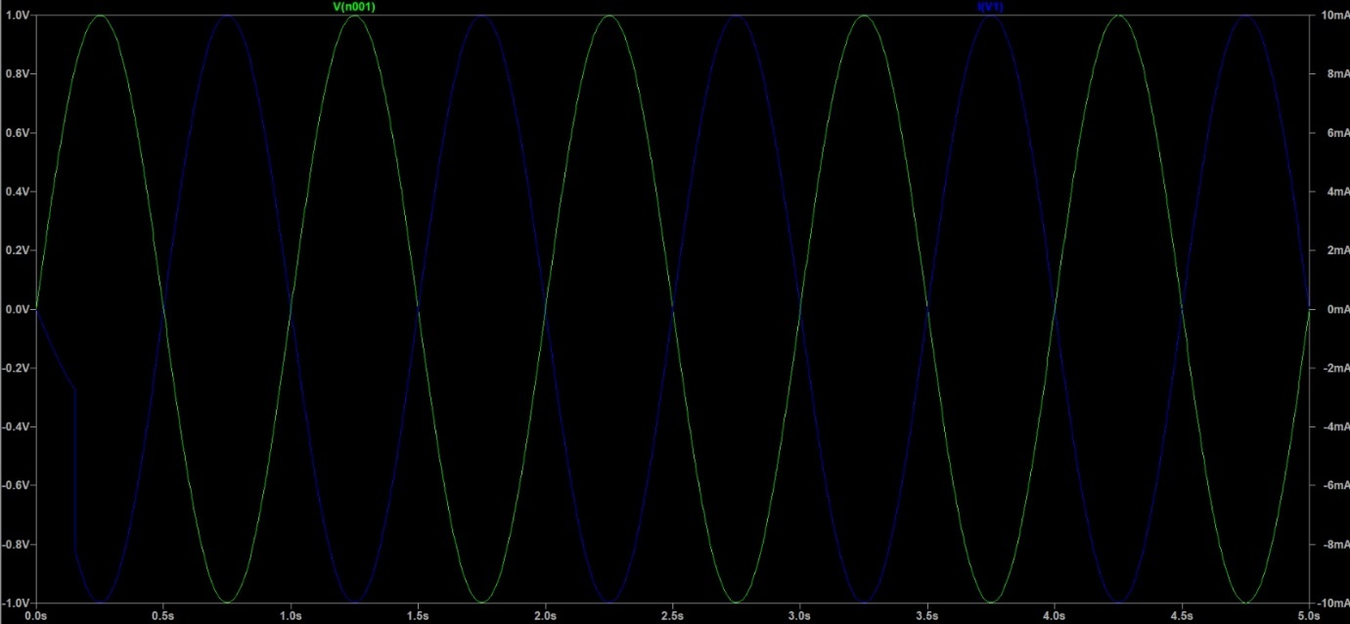

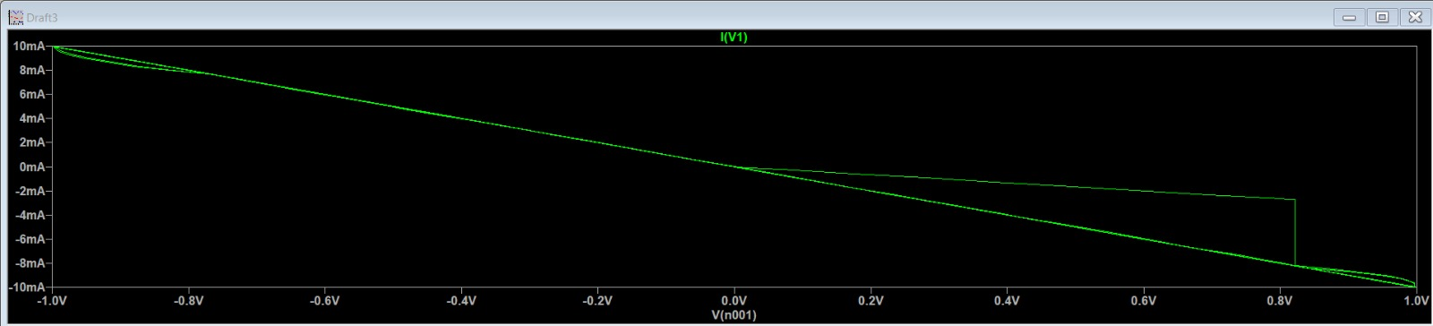

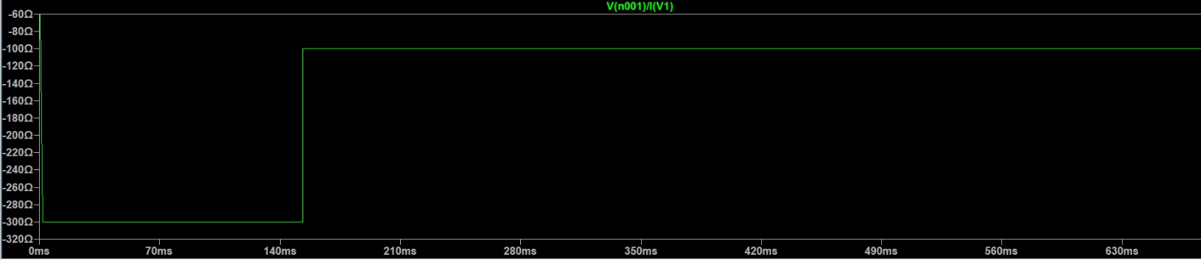

## Part c

For this part we will simulate the circuit with three setups in order to determine the effect of both a1 and a2 parameters on the model. Following setups:

**a1=a2=10:**

**a1=3, a2=10:**

**a1=10, a2=3:**

Analytically we can conclude that the a1, and a2 effect the change ratio of the state variable w/D, where a1 effects the positive change ratio and a2 effect the negative change ratio hence when a1=a2 we will always get perfectly symmetric square wave as the resistivity plot. When a1 and a2 differ from each other like in plots 2+3 the resistivity plot will behave like a square wave with certain duty cycle like a PWM signal, however if the difference is big enough like in the graphs above the memristor will get stuck at due to small effect in the positive/negative change ratio of the state variable hence the resistivity will not be able to transition.

## Part d

After building the circuit the following voltage, current, and resistance is displayed, the red graph is calculated by dividing the voltage over the current on the power source hence we get the total resistivity of the three-resistor circuit.

The total resistivity plot has multiple discontinuities every time one of the resistors transitions from R_on to R_off or vise versa the total resistivity is changed, the two parallel resistors change together since the current through them is equivalent, and the other resistor which is in parallel will also transition on a different frequency than the other two memristors…. Hence, we get a harmonic behavior of the three memristors transitioning one by one and affecting the total resistivity…

